Clyde Lovellette inducted today
By Gary Bedore, KUSports, November 18, 2012
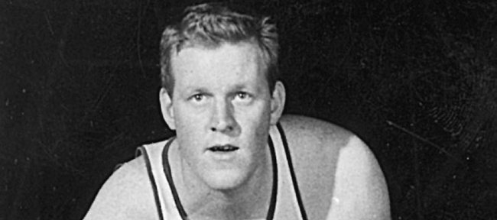
Though he played just three years, Clyde Lovellette is KU's fourth-leading scorer with 1,979 points
Clyde Lovellette says he is humbled and honored by today’s induction into the National Collegiate Basketball Hall of Fame.
“I think it’s great. It’s always great to get recognized as old as I am,” joked the 83-year-old former Kansas University center, who is a member of the 10-person Class of 2012. Others to be inducted in a 7:30 p.m. ceremony at The Midland in Kansas City, Mo.: Patrick Ewing (Georgetown), Phil Ford (North Carolina), Joe B. Hall (Kentucky), Dave Robbins (Virginia Union), Kenny Sailors (Wyoming), Earl Monroe (Winston Salem State), Willis Reed (Grambling), Jim Host (founded Host Communications) and Joe Dean (Louisiana State University).
“At the University of Kansas, I had a lot of great honors,” the 6-foot-10, three-time All-American told the Journal-World in a phone interview. He currently lives in North Manchester, Ind.
“There’s the 1952 (national title) team, the Olympic gold medal (’52 in Helsinki), the (Naismith Memorial) Hall of Fame in Springfield, Mass., and now this one in Kansas City. I always said the gold medal was the greatest one because it was for the United States, Kansas, Kansas University and myself and the team. The Hall of Fame is such an honor. I credit all the guys I played with at the University of Kansas. Without them, I wouldn’t be where I am today.”
Lovellette’s KU teammate, Bill Lienhard, is to introduce Lovellette at the ceremony.
“Clyde was really dominant in his day,” Lienhard said. “If he had the ball around the basket, he got it in there. He was not only a good scorer, but a good shooter.
“You couldn’t dunk in 1952. He had to shoot to get everything in the basket for 28 points a game. Everybody likes Clyde,” Lienhard added of the three-time NBA champion (twice with Boston, once with Minneapolis). “Clyde is a real gentleman, born-again Christian and great guy.”
He also was a “tough guy,” Lienhard added.
“If anybody guarded him too close ... he had a sweeping hook shot,” Lienhard said. “That left elbow would go out when he went in (toward goal). More than one center got an elbow in his jaw on the turn. He was a good scorer, rebounder and very tough.”
Lovellette was the first player to win championships in the NCAA, AAU, NBA and Olympics. He led the Big Seven Conference in scoring in each of his three seasons. He was the country’s top scorer in 1952 at 28.6 points per game and was named the Most Outstanding Player of the 1952 NCAA Tournament. He ranks as the No. 4 scorer in KU history with 1,979 career points (24.7 ppg) and No. 11 all-time leading rebounder with 813 (10.2 rpg). He had a 12-year NBA career with stops at Minneapolis, Cincinnati, St. Louis and Boston. Since retiring from hoops after the 1964 season, he worked in the area of law enforcement and juvenile counseling in his native state of Indiana.
He was elected to the KU Athletics Hall of Fame in May, 1988.

